Design: CFLEX2.0 User Login

Overview

Requirement:
- Flex User should able to login into new FLEXGUI.

Scope:
User login for FLEX_MAIN session

Implementation

2.1 IDL Changes

2.1.1 CMI IDL Modification
- None

Other IDL Modification:
- None

3. Global Server

3.1 Classes & Interfaces
- None

3.2 Scripts
- None

3.3 Database Changes
- None

3.4 Jars/Wars
- client_webImpls.jar
The Jar file is added in classpath and classes which is built from new WebCas VOB webImpls. This jars also needs few supporting jars to build the code and added in classpath which are as follows-
- bayeux-api-2.1.1.jar
- cometd-java-annotations-2.1.1.jar
- cometd-java-client-2.1.1.jar
- cometd-java-common-2.1.1.jar
- cometd-java-server-2.1.1.jar
- javax.inject-1.jar
- jetty-6.1.11.jar
- jetty-util-6.1.11.jar
- jetty-client-7.3.1.v20110307.jar
- jetty-http-7.3.1.v20110307.jar
- jetty-io-7.3.1.v20110307.jar
- jetty-util-6.1.11.jar
- jetty-util-7.3.1.v20110307.jar
- jsr250-api-1.0.jar
- servlet-api-2.5-6.1.11.jar
- WebCas.War
This war file contains all web related code which is deployed on Jetty server running on CAS. This uses client_webImpls.jar after dispatching the data to CAS services.

3.5 XML/DTD

Following Xml and dtd files are changed/added in CAS to configure Jetty server and deploy the war file.
- Jettyprod.xml
New xml file added to configure the Jetty server properties
- war_descriptor.xml
New xml file added to mention the name and path of the war file to be deployed on CAS for cometd Services.
- JettyService.xml
New xml file added for configuration file used by JettyServiceHomeImpl to point out Jettyprod.xml
- WebCasInProcessFlexTradeServiceHome.xml
New xml file added to configure the properties required for WebCasInProcessFlexTradeService.
- CAS.xml
Added the newly created home for flexsession for deployement.
- processes.cas.xml
Added the changes for adding cometd and Jetty jars in classpath and loading new Xml files in filelist.
- JettyService.dtd
New dtd file added to define JettyService.xml
- WebCasInProcessFlexTradeServiceHome.dtd
New dtd file added to define WebCasInProcessFlexTradeServiceHome.xml
- configure.dtd
New dtd file added to define tags in Jettyprod.xml

4. Client

WebCAS Changes

4.1.1 Classes & Interfaces
- ConfigurationServlet.java
This servlet is used by cometd to initialize all the Services deployed and to setup the authenticator used to authenticate the user data. This Servlet is loaded using web.xml while server startup. It initializes all the services like LoginService.java, LogoutService.java, and ProductQueryService.java

- LoginService.java
Receives the message from client over specific CometD channel. The channel on which data is received and which method will be called after receiving message is configured here. The Client passes the action performed details along with the data in a Map. The instantiation happens only once when the application starts.

- WebCasLoginDispatcherFactory.java
This class creates the appropriate dispatcher depending on the actionID send by the client while publishing data.

- WebCasLoginDispatcher.java
This class takes the message from LoginService and translates it into the CMI struct and dispatches the message to respective home for processing.

- WebCasAdapter.java
This is an interface which is implemented by WebCasAdapterImpl.java and has methods for creating and fetching Wcassession.The sessions can be fetched by providing SessionId which will be sessionId of cometd ServerSession.

- WebCasAdapterImpl.java
This class implements WebCasAdapter and BOObject. It validates for Session already exists or user already logged in and if not it initiates WebCasSession. This adapter is singleton and stores the map of user sessions.

- WebCasAdapterHome.java
This is deployed in CAS a service and has implemented by WebCasAdapterHomeImpl.java

- WebCasAdapterHomeImpl.java
This class is an implantation of WebCasAdapterHome.java and it instantiates the singleton object of WebCasAdapterImpl.java

- WebCasSession.java
Manages a WebCas session for a logged in FLEX user. CAS login initialization
is done by creating an instance of WebCasAccessManager and calling initialize() method.

- WebCasAccessManager.java
Manages access to CAS, including logging on to the CAS, returning object references to CAS Interfaces, creation and registration of the UserSessionAdmin callback object. This holds the WebCasInProcessSessionManager instance specific to the logged in user.

- WebCasInProcessSessionManager.java
This interface extends SessionManager and newly created SessionManagerV10 interface and contains all the methods to fetch the existing CAS service interfaces like getInProcessProductQuery () which returns ProductQueryManager.

- WebCasInProcessSessionManagerImpl.java
This is the implementation of the WebCasInProcessSessionManager interface that maintains all the user specific API object connections for a client into the CAS.

- WebCasInProcessSessionManagerHome.java
This is the home for service deployed in the existing CAS and would be implemented by WebCasInProcessSessionManagerHomeImpl.java.

- WebCasInProcessSessionManagerHomeImpl.java
This is the implementation of the WebCasInProcessSessionManagerHome which creates instance WebCasInProcessSessionManagerImpl.

- InProcessServicesHelper.java
This class is an existing class which is used to get reference of the service deployed in CAS which calls the homefactory to fetch home and then create service to return.

- WcasUserSessionAdminConsumer.java
This interface is used for registering callback object like acceptLogout() and acceptTextMessage(().

- WcasUserSessionAdminConsumerImpl.java
This is an implementation of WcasUserSessionAdminConsumer interface.

- WebCasUtilMapper.java
This class will contain static mapping classes that map between FLEX Gui Struct implementation and the CMi struct.

- WebCasConstants.java
This Class will contain all the constants used to map the FlexGui data with CMI constants.

- WebCasUserAccess.java
This is the interface for Cas user logon method which would take the UserLogonStruct and WcasUserSessionAdminConsumer as input.

- WebCasUserAccessImpl.java
This is the implementation of WebCasUserAccess interface which has logon method which authenticates user.

- WebCasUserAccessHome.java
This class will be used as flex user login service deployed on CAS.

- WebCasUserAccessHomeImpl.java
This is the implementation of WebCasUserAccessHome service which creates WebCasUserAccessImpl.

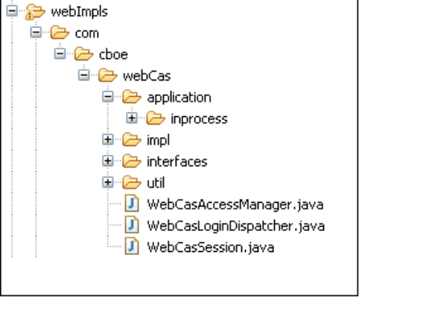

Package Details:

Package | Class Name
com.cboe.webCas.interfaces.application.inprocess | WebCasInProcessSessionManager
com.cboe.webCas.application.inprocess.session | WebCasInProcessSessionManagerImpl
com.cboe.webCas.interfaces.application.inprocess | WebCasInProcessSessionManagerHome
com.cboe.webCas.application.inprocess.session | WebCasInProcessSessionManagerHomeImpl
com.cboe.webCas.interfaces | WebCasLoginAdapter
com.cboe.webCas.impl | WebCasLoginAdapterImpl
com.cboe.webCas.interfaces | WebCasLoginAdapterHome
com.cboe.webCas.impl | WebCasLoginAdapterHomeImpl
com.cboe.webCas | WebCasAccessManager
com.cboe.webCas | WebCasLoginDispatcher
com.cboe.webCas | WebCasSession
com.cboe.application.inprocess.shared | WebCasInProcessServicesHelper
com.cboe.webCas.impl | WebCasUserSessionAdminConsumerImpl
com.cboe.webCas.interfaces | WebCasUserSessionAdminConsumer
com.cboe.webCas.util | WebCasUtilMapper
com.cboe.webCas.util | WebCasConstants
com.cboe.webCas.interfaces | WebCasUserAccess
com.cboe.webCas.impl | WebCasUserAccessImpl
com.cboe.webCas.interfaces | WebCasUserAccessHome
com.cboe.webCas.impl | WebCasUserAccessHomeImpl

Sequence diagram:

Existing FixCas Login flow :
CasLogonDispatcher
dispatch()
CasAppiaAdapterImpl
createSession()
createFixCasSession()
new FixCasSession()
FixCasSession
intialize()
initiateCasLogon()
CasAccessManager
UserAccessImpl
logon()
userSessionManager()
InProcessServicesHelper
logon()()
createSessionManager()
verifyPassword()
registerWithSMS()
UserSessionManager()

New Webcas Login flow:
LoginService
WebCasLoginDispatcher
dispatch(remote, data)()
WebCasLoginAdapterImpl
createSession()
WebCasSession
initialize()
WebCasAccessManager
initiateCasLogon()
InProcessServicesHelper
logon()
WebCasUserAccessImpl
createSessionManager()
WebCasInProcessSessionManagerH
omeImpl
createInProcessSession()
WebCasInProcessSessionManagerI
mpl
initialize()
Publish()
getUserLogonStruct()
WebCasAccessManager()
WebCasUserSessionAdminConsumer
Impl
WebCasUserSessionAdminConsumerImpl()
verifyPassword()
registerWithSMS()
WebCasDispatcherFactory
createDispatcher()
Only this compoent will reside in War file
Message1()
createWebCasSession()
getUserAccess()
logon()
Client 1
WebCasInProcessSessionManager()
WebCasInProcessSessionManager()

5. GUI

5.1 FlexGUI Changes

5.1.1 Changes for Login Screen
We need to create below mentioned files for giving a call to WCAS for logon.

1. ClientListener.java
A common interface, which would be used by the implemented by the API’s to subscribe a channel.

2. LoginPanel.java
A new panel for FLEX GUI through which, a user would enter user id and password.

3. LoginAPI.java
This class would be giving a call to WCAS using cometD by publishing the user id and password on login channel.
When we publish user id and password, GUI would be using time out
We would be creating a listener which would continue listening on the login and logout channel. If it receives any message for Force Logout from WebCAS, it would show a pop-up message to user and close the GUI.

4. Resources.java
It loads resource bundles for the application.

5. HomeBuilder.java
This would initialize the list of homes required for FLEX GUI.

6. FlexAPIHome.java
Create a home to build the FlexAPIFactories to locate various Translator API services among client apps.
7. FlexAPIFactory.java
New Interface which defines a common definition for a FlexAPIFactory.

8. FlexAPIFactoryImpl.java
It would be implementing all the finders for a FlexAPIFactory for the FLEX GUI.

9. GUILogger.java
This class would provide a proxy with initialization of the logger engine.

10. ApplicationMain.java
Create a new class to launch the Flex GUI.

11. AppPropertiesFileImpl.java
Create a class to implement the Properties File for all the FLEX GUI properties.

12. ClientSession.java
This class would maintain a single BayeuxClient session. All the API’s of GUI would be using the same session to publish the data on all the channels.
After initializing the client session, it would give a call to JASONHelper to register the object for conversion.
This class would also have a method named sendDatatoWebCAS(String, Map) which would be called by API to publish data on a given channel.

13. JASONHelper.java
This class would have the Jetty7 JSON implementation to include a JSONPojoConverterFactory that can be registered objects to convert into JASON String and vice-versa.

14. MainWindow.java
Add Login Panel in the main window. When user successfully logged in, we would hide the login panel.

15. CFlexAppProperties.java
Add methods to read connection related properties from property file like CAS name, port number and default URL.

16. SbtFlexGui.properties
Add property for CAS name, port number and default URL.

5.1.3 Sequence Diagram:
  - Existing Trader GUI Flow:

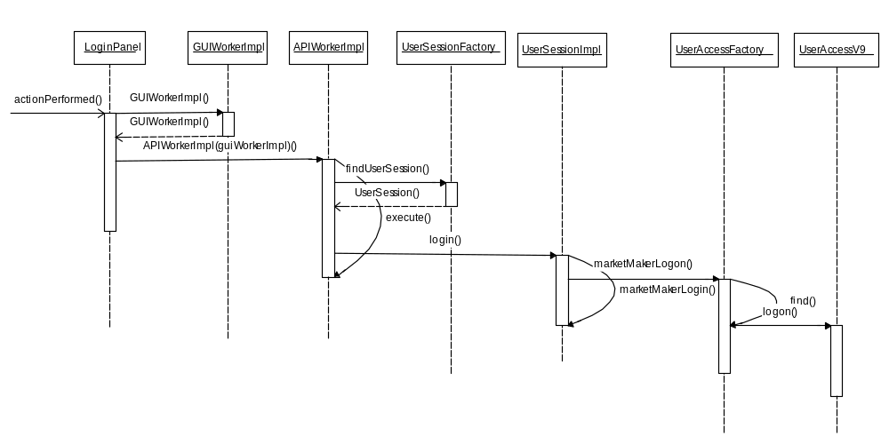

  - FLEX GUI Flow:

